|  |  |  |
| --- | --- | --- |
| Image result for latest marwadi university logo | **Marwadi University**  **Faculty of Technology**  **Department of Information and Communication Technology** | |
| **Subject: DSC  (01CT0308)** | Aim: Implementations of circular queue menu-driven program. | |
| **Experiment No: 4** | **Date: 20- 10 - 2023** | **Enrolment No:-** 92200133030 |

**Experiment – 4**

**Objective:** Implementations of circular queue menu-driven program.

**Code :-**

1. **Using Array**

#include <iostream>

using namespace std;

class CircularQueue {

private:

int size;

int front;

int rear;

int* queue;

public:

CircularQueue(int n) {

size = n;

front = -1;

rear = -1;

queue = new int[size];

}

bool isEmpty() {

return front == -1;

}

bool isFull() {

return (rear + 1) % size == front;

}

void enqueue(int num) {

if (isFull()) {

cout << "Queue Is Full." << endl;

return;

} else {

if (isEmpty()) {

front = rear = 0;

} else {

rear = (rear + 1) % size;

}

queue[rear] = num;

cout << num << " Is Enqueued In Your Queue." << endl;

}

}

void dequeue() {

if (isEmpty()) {

cout << "Queue Is Empty." << endl;

return;

} else {

int dequeued = queue[front];

if (front == rear) {

front = rear = -1;

} else {

front = (front + 1) % size;

}

cout << dequeued << " Is Dequeued From Your Queue." << endl;

}

}

void display() {

if (isEmpty()) {

cout << "Queue is Empty." << endl;

} else {

cout << "Your Queue Is: ";

if (front <= rear) {

for (int i = front; i <= rear; i++) {

cout << queue[i] << " ";

}

} else {

for (int i = front; i < size; i++) {

cout << queue[i] << " ";

}

for (int i = 0; i <= rear; i++) {

cout << queue[i] << " ";

}

}

cout << endl;

}

}

int getFront() {

return queue[front];

}

int getRear() {

return queue[rear];

}

};

int main() {

int size;

int num;

cout << "Implementation Of Circular Queue " << endl;

cout << "Enter The Size Of Your Queue:-" << endl;

cin >> size;

CircularQueue circularqueue(size);

int choice = -1;

do {

cout << "Circular Queue Menu:- " << endl;

cout << "1) Enqueue" << endl;

cout << "2) Dequeue" << endl;

cout << "3) Display Queue" << endl;

cout << "4) Check if Empty" << endl;

cout << "5) Check if Full" << endl;

cout << "6) Get Front Element" << endl;

cout << "7) Get Rear Element" << endl;

cout << "8) Quit" << endl;

cout << "Enter Your Choice To Perform The Operation On Queue:- ";

cin >> choice;

switch (choice) {

case 1: {

cout << "Enter The Number To Enqueue In Your Queue:- ";

cin >> num;

circularqueue.enqueue(num);

break;

}

case 2: {

circularqueue.dequeue();

break;

}

case 3: {

circularqueue.display();

break;

}

case 4: {

if (circularqueue.isEmpty()) {

cout << "Queue is empty." << endl;

} else {

cout << "Queue is not empty." << endl;

}

break;

}

case 5: {

if (circularqueue.isFull()) {

cout << "Queue is full." << endl;

} else {

cout << "Queue is not full." << endl;

}

break;

}

case 6: {

if (!circularqueue.isEmpty()) {

cout << "Front element: " << circularqueue.getFront() << endl;

} else {

cout << "Queue is empty." << endl;

}

break;

}

case 7: {

if (!circularqueue.isEmpty()) {

cout << "Rear element: " << circularqueue.getRear() << endl;

} else {

cout << "Queue is empty." << endl;

}

break;

}

case 8: {

cout << "Program Ends!" << endl;

return 0;

}

default: {

cout << "Enter a valid choice." << endl;

break;

}

}

} while (choice != 8);

return 0;

}

**Output:**

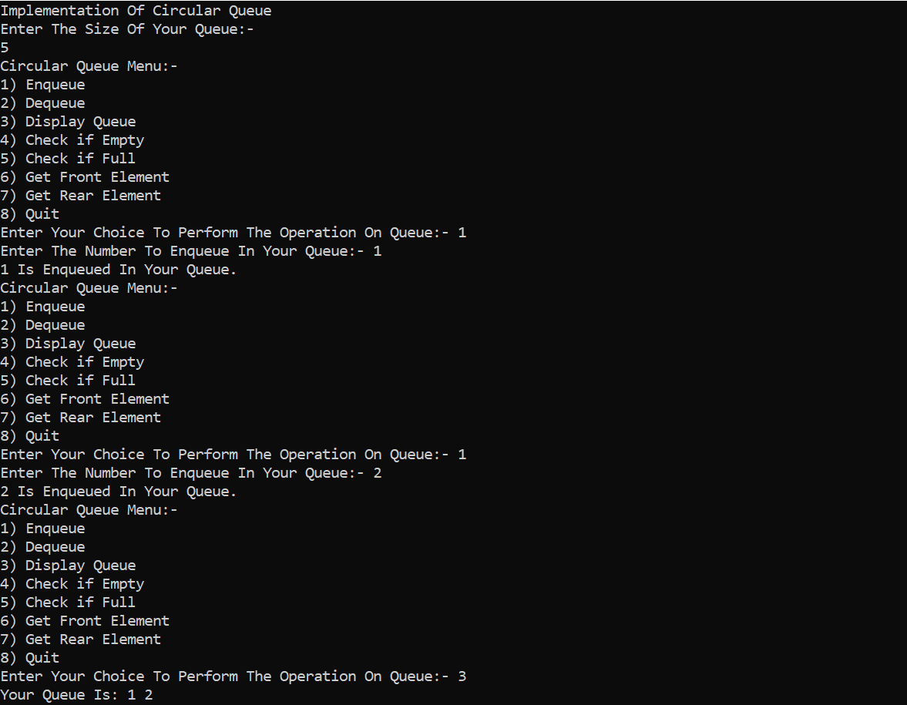

1. **Using LinkedList**

#include <iostream>

using namespace std;

class Node {

public:

int data;

Node* next;

Node(int val) {

data = val;

next = NULL;

}

};

class CircularQueue {

private:

Node* front;

Node* rear;

int size;

int no_of_elements = 0;

public:

CircularQueue(int num) { // Added public access specifier

front = NULL;

rear = NULL;

size = num;

}

bool isEmpty() {

return front == NULL;

}

bool isFull() {

return no_of_elements == size;

}

void enqueue(int num) {

if (isFull()) {

cout << "Queue Is Full." << endl;

return;

}

Node* n = new Node(num);

if (isEmpty()) {

front = n;

} else {

rear->next = n;

}

rear = n;

rear->next = front;

no_of_elements++; // Increment the number of elements

cout << num << " Is Enqueued In Your Queue." << endl;

}

void dequeue() {

if (isEmpty()) {

cout << "Queue Is Empty." << endl;

} else {

int remove = front->data;

if (front == rear) {

delete front;

front = rear = NULL;

} else {

Node* todelete = front;

front = front->next;

rear->next = front;

delete todelete;

}

no_of_elements--; // Decrement the number of elements

cout << remove << " Is Dequeued From Your Queue." << endl;

}

}

void display() {

if (isEmpty()) {

cout << "Queue Is Empty." << endl;

} else {

Node* temp = front;

cout << "Your Queue Is: ";

do {

cout << temp->data << " ";

temp = temp->next;

} while (temp != front);

cout << endl;

}

}

int getFront() {

return front->data;

}

int getRear() {

return rear->data;

}

};

int main() {

int size;

int num;

cout << "Implementation Of Circular Queue " << endl;

cout << "Enter The Size Of Your Queue:-" << endl;

cin >> size;

CircularQueue circularqueue(size);

int choice = -1;

do {

cout << "Circular Queue Menu:- " << endl;

cout << "1) Enqueue" << endl;

cout << "2) Dequeue" << endl;

cout << "3) Display Queue" << endl;

cout << "4) Check if Empty" << endl;

cout << "5) Check if Full" << endl;

cout << "6) Get Front Element" << endl;

cout << "7) Get Rear Element" << endl;

cout << "8) Quit" << endl;

cout << "Enter Your Choice To Perform The Operation On Queue:- ";

cin >> choice;

switch (choice) {

case 1: {

cout << "Enter The Number To Enqueue In Your Queue:- ";

cin >> num;

circularqueue.enqueue(num);

break;

}

case 2: {

circularqueue.dequeue();

break;

}

case 3: {

circularqueue.display();

break;

}

case 4: {

if (circularqueue.isEmpty()) {

cout << "Queue is Empty." << endl;

} else {

cout << "Queue is not Empty." << endl;

}

break;

}

case 5: {

if (circularqueue.isFull()) {

cout << "Queue is Full." << endl;

} else {

cout << "Queue is not Full." << endl;

}

break;

}

case 6: {

if (!circularqueue.isEmpty()) {

cout << "Front Element: " << circularqueue.getFront() << endl;

} else {

cout << "Queue is Empty." << endl;

}

break;

}

case 7: {

if (!circularqueue.isEmpty()) {

cout << "Rear Element: " << circularqueue.getRear() << endl;

} else {

cout << "Queue is Empty." << endl;

}

break;

}

case 8: {

cout << "Program Ends!" << endl;

return 0;

}

default: {

cout << "Enter a valid choice." << endl;

break;

}

}

} while (choice != 8);

return 0;

}

**Output:**

